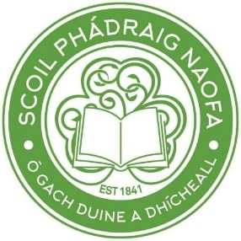

St. Patrick’s Boys’ National School
ANNUAL ADMISSION NOTICE
in respect of admissions to the 2021/2022 school year
-This Notice must be published at least 1 week before a school can accept applications for admission
-This Notice must be published on the school’s website and must remain there for the duration of the school year
-This Notice must also be made available on written request
Admission Policy and Application Form
A copy of the school’s Admission Policy and the Application Form for Admission for the 2021/2022 is available as follows: –
To download at: www.stpatricksboys.net
On request: By emailing stpatricksboysschool@gmail.com or writing to: St. Patrick’s Boys’ National School, Gardiner’s Hill, Cork City

PART 1 - Admissions to the 2021/2022 school year

Application and Decision Dates for admission to 2021/2022

The following are the dates applicable for admission to First Class

The school will commence accepting applications for admission on 15th January 2021

The school shall cease accepting applications for admission on (subject to the NCSE Application for Supports deadline) (minimum period of 3 weeks between this date and the commencement date for accepting applications for admission)

The date by which applicants will be notified of the decision on their application is
(This date must be within 3 weeks of the closing date for receipt of application or within 3 weeks of the application date for late applications)
The period within which applicants must confirm acceptance of an offer of admission is

*Failure to accept an offer within the prescribed period above may result in the offer being withdrawn
Note: the school will consider and issue decisions on late applications in accordance with the school’s admission policy.

Number of places being made available in 2021/2022

The number of places being made available in 1st Class is

